Department of Computer Systems Engineering
Mehran University of Engineering and Technology, Jamshoro
Course: Database Management Systems (CS-253)
Instructor | Engr. Kashaf Agha | Assignment Type | Complex Engineering Problem
Semester | 4th | Year | 2nd
Submission Deadline | 22-04-26 | Assessment Score | 10
Student Name | Muhammad Mubashar | Roll Number | 24CS056

Complex Engineering Problem - Characteristics
1 | Depth of knowledge Required
2 | Range of Conflicting Requirements
3 | Depth of Analysis Required
4 | Infrequently Encountered Issues Involved
5 | Beyond codes/standards of practice
6 | Diverse groups of stakeholders with widely varying needs involved
7 | Interdependence (high-level problems including many component parts/sub-problems)
8 | Have significant consequences in a range of contexts
9 | Judgment (Require judgment in decision making)

Problem Description
Develop a comprehensive database system for a real-world application of your choice. The system must demonstrate core concepts of Database Management Systems, including database design, normalization, query processing, and transaction management.
The project should focus on efficient data organization, integrity, and retrieval while simulating real-world operations and constraints.
Application areas may include but are not limited to; health care, education, industry, transport, supply chain, business, human resource management, manufacturing, etc. Marking will be done on the following parameters:
- Schema
- Normalization
- Constraints
- Queries
- Transactions

Database Management System Project Report
Hospital Management System (MediCare HMS)

1. Introduction
The MediCare Hospital Management System is designed to provide efficient data organization, retrieval, and management for a real-world healthcare environment. The integrated database manages core operational functionalities including patient records, doctor scheduling, appointment management, ward/bed allocations, and billing systems.

1.1 Objectives
- Streamline the management of hospital resources, including doctors, patients, wards, and beds.
- Implement a robust normalized database to eliminate data anomalies and inconsistencies.
- Provide seamless handling of day-to-day operations such as appointment booking, monitoring bed availability, and generating accurate billing.
- Enforce strict data integrity using primary/foreign keys, domain constraints, and transaction management.
- Guarantee accurate data retrieval using optimized multi-table JOINs and analytical aggregation queries.

1.2 Key Features
- Patient Management: Demographics, dynamic token generation, and secure historical tracking.
- Doctor & Appointment Management: Linking profiles, availability matrices, and status workflows (Pending, Confirmed, Cancelled, Completed).
- Infrastructure Handling: Visual ward monitoring and real-time bed occupancy toggling.
- Financial Billing: Comprehensive invoicing mechanisms mapping separated logic for line-items vs grand-totals.
- Role-Based Auth: Secure separation of administrative, doctor, and receptionist interfaces.

2. User Interface (Screenshots)

2.1 Login Interface
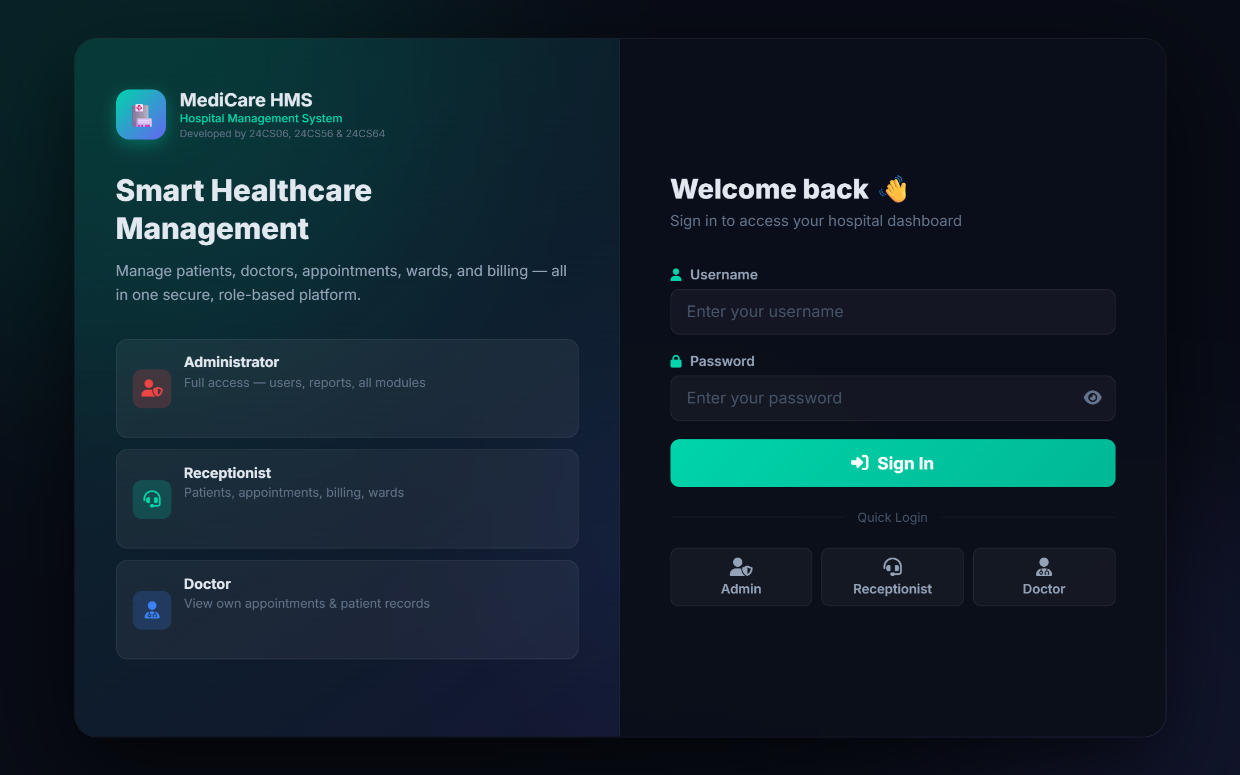

2.2 Dashboard Analytics
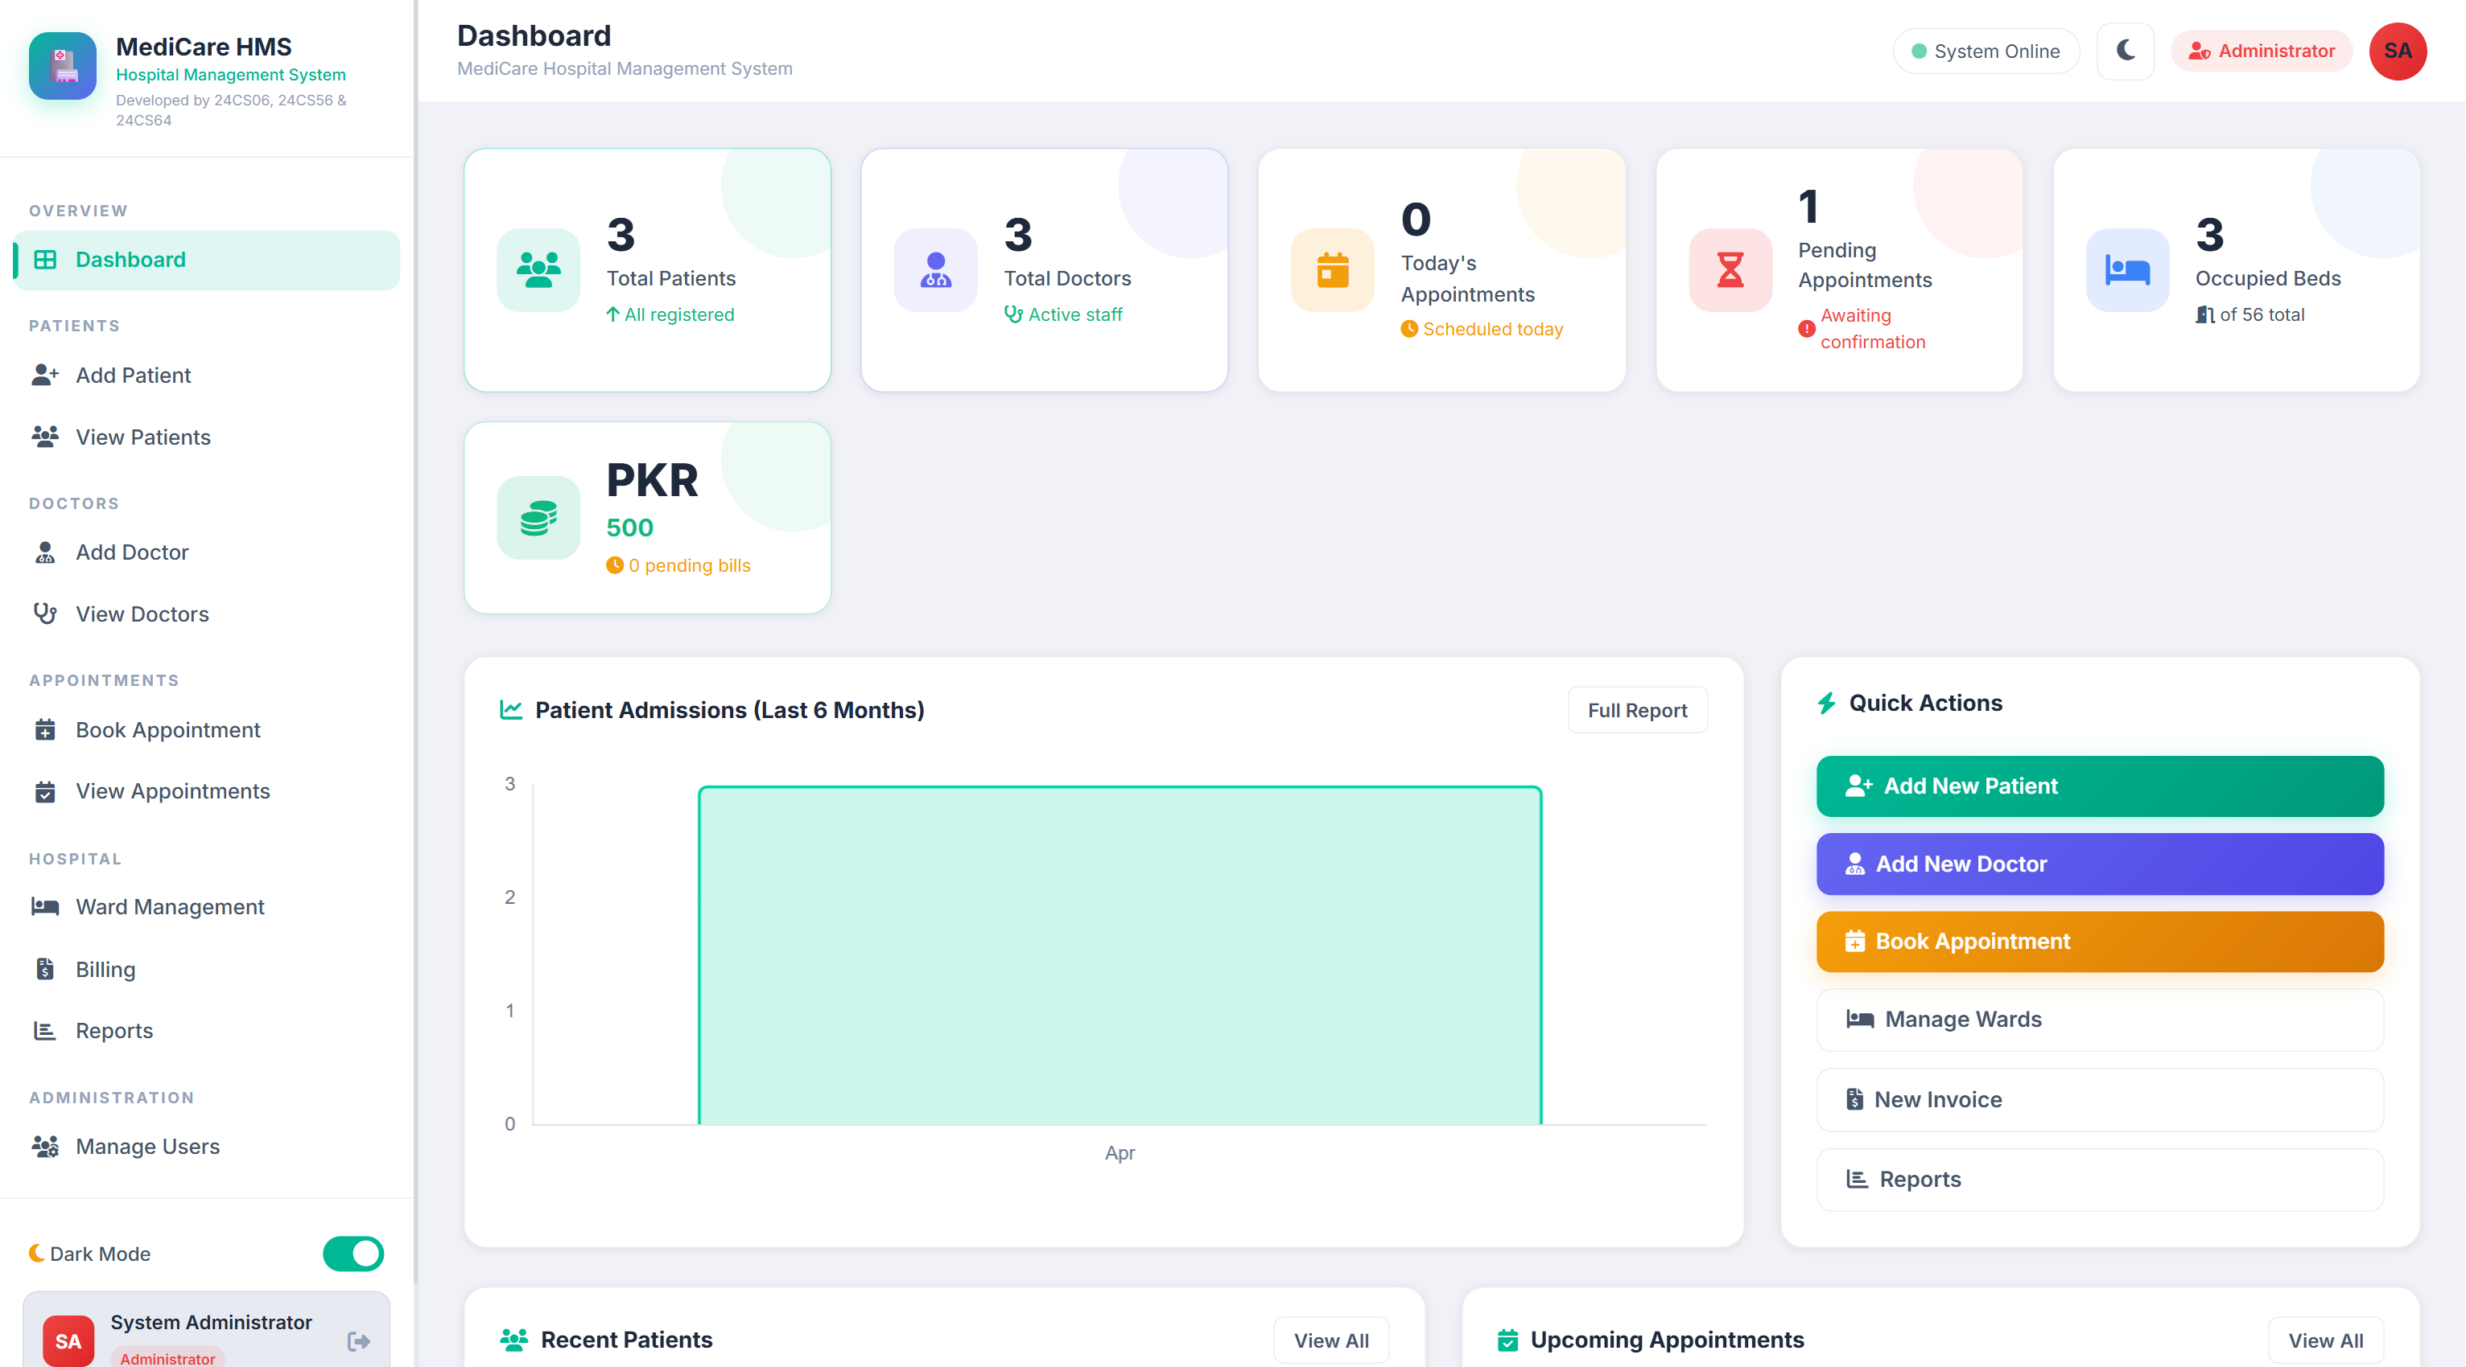
Admin View
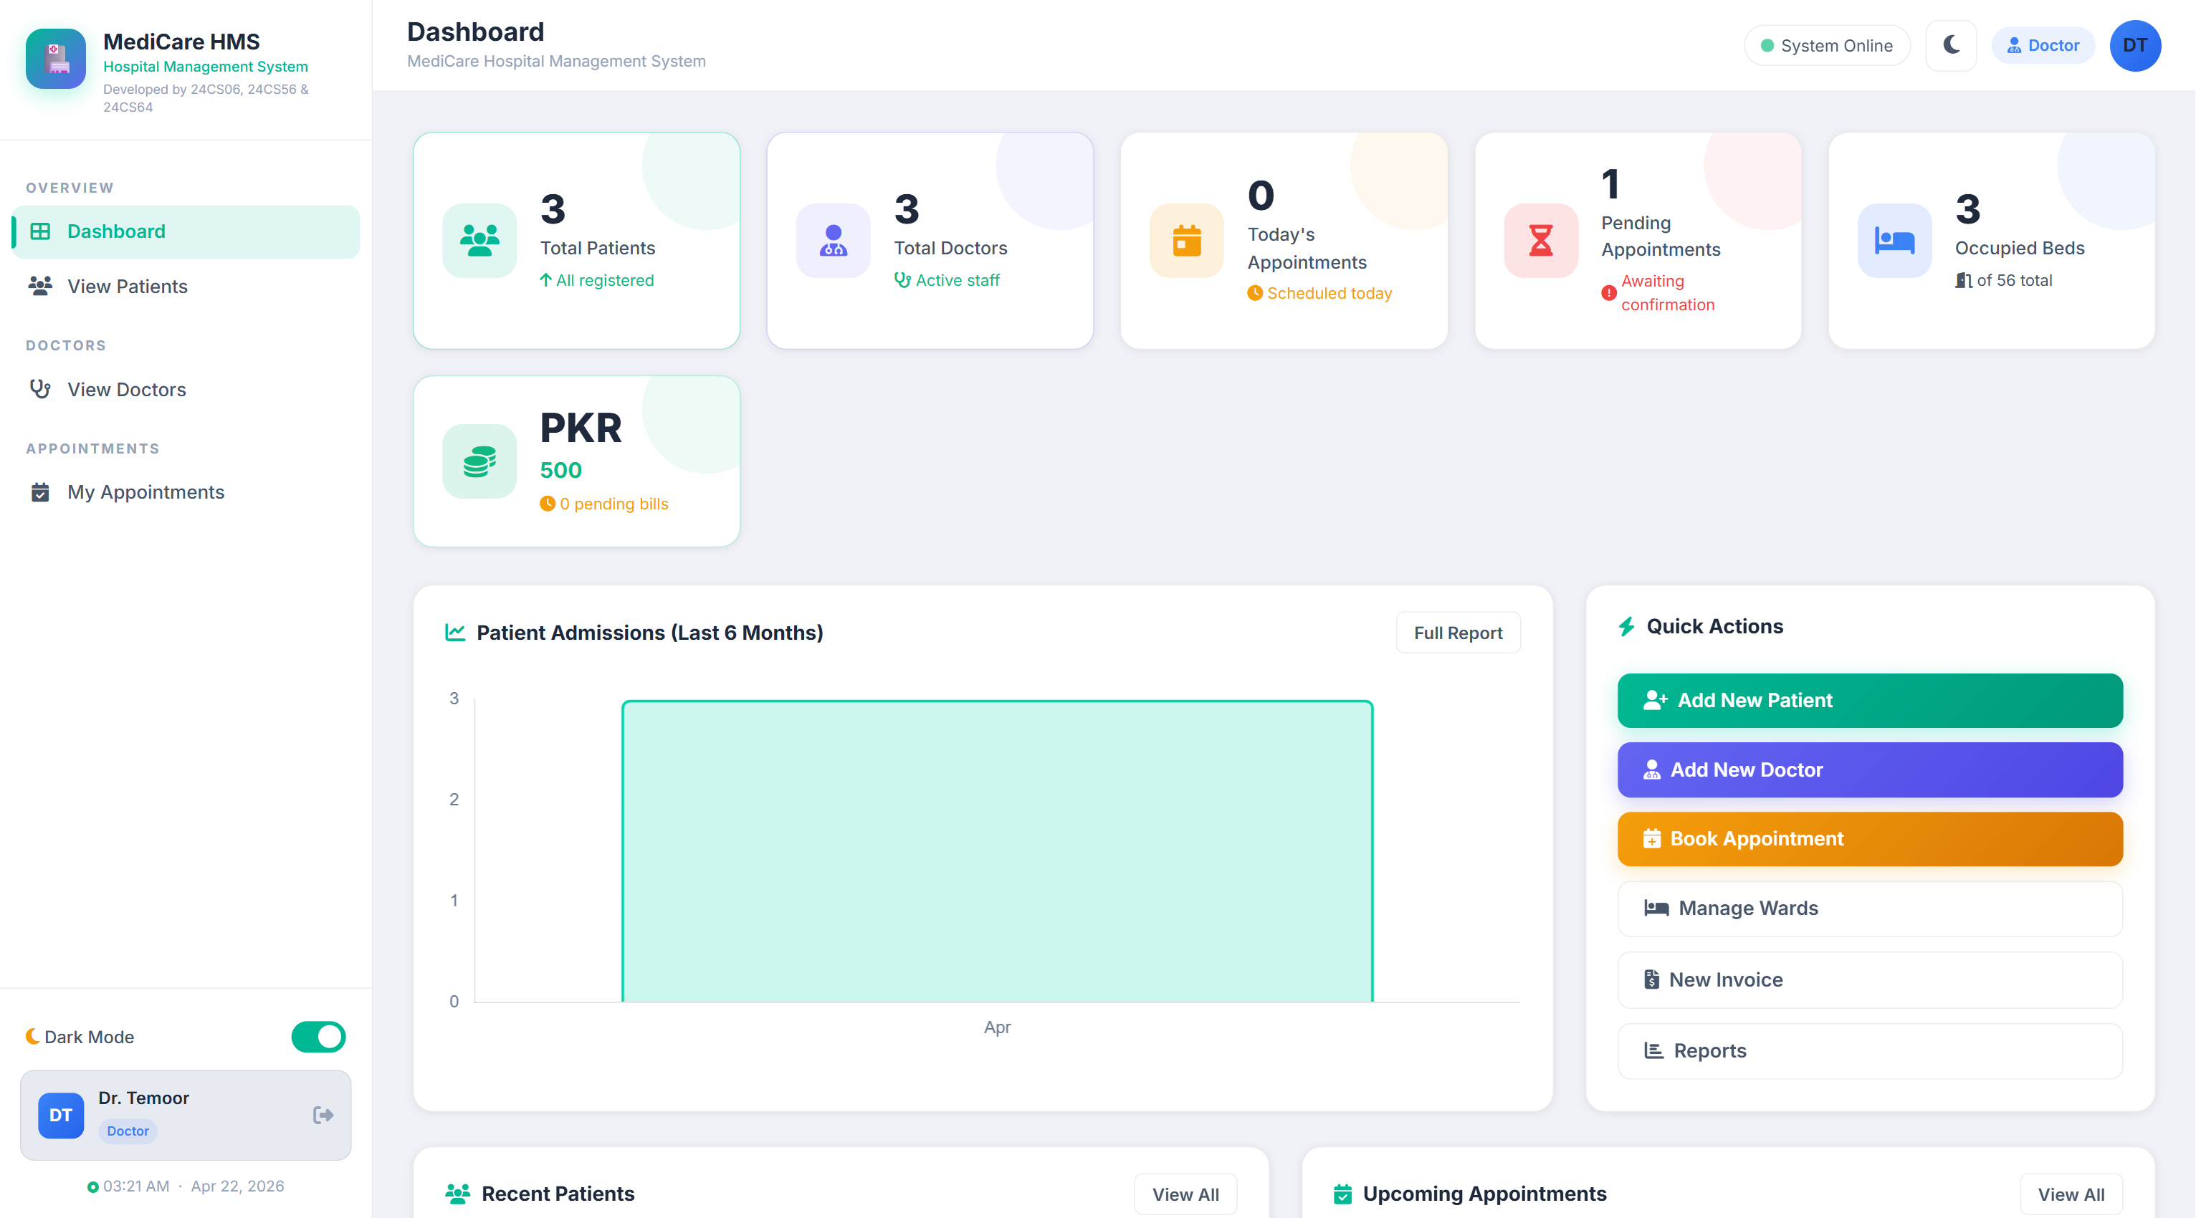
Doctor View

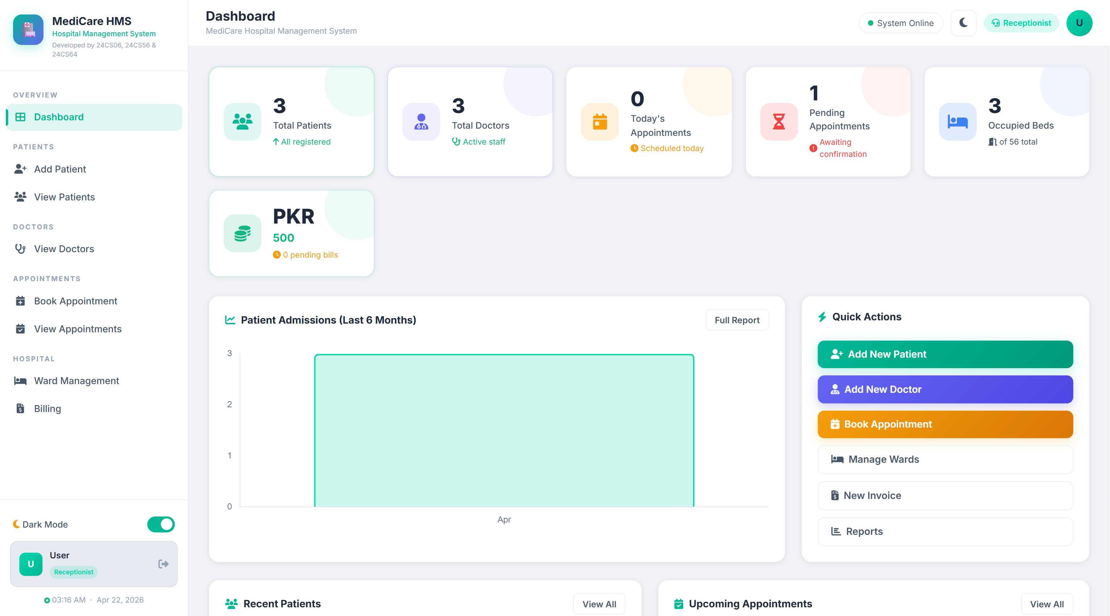
Receptionist View

2.3 Billing Module
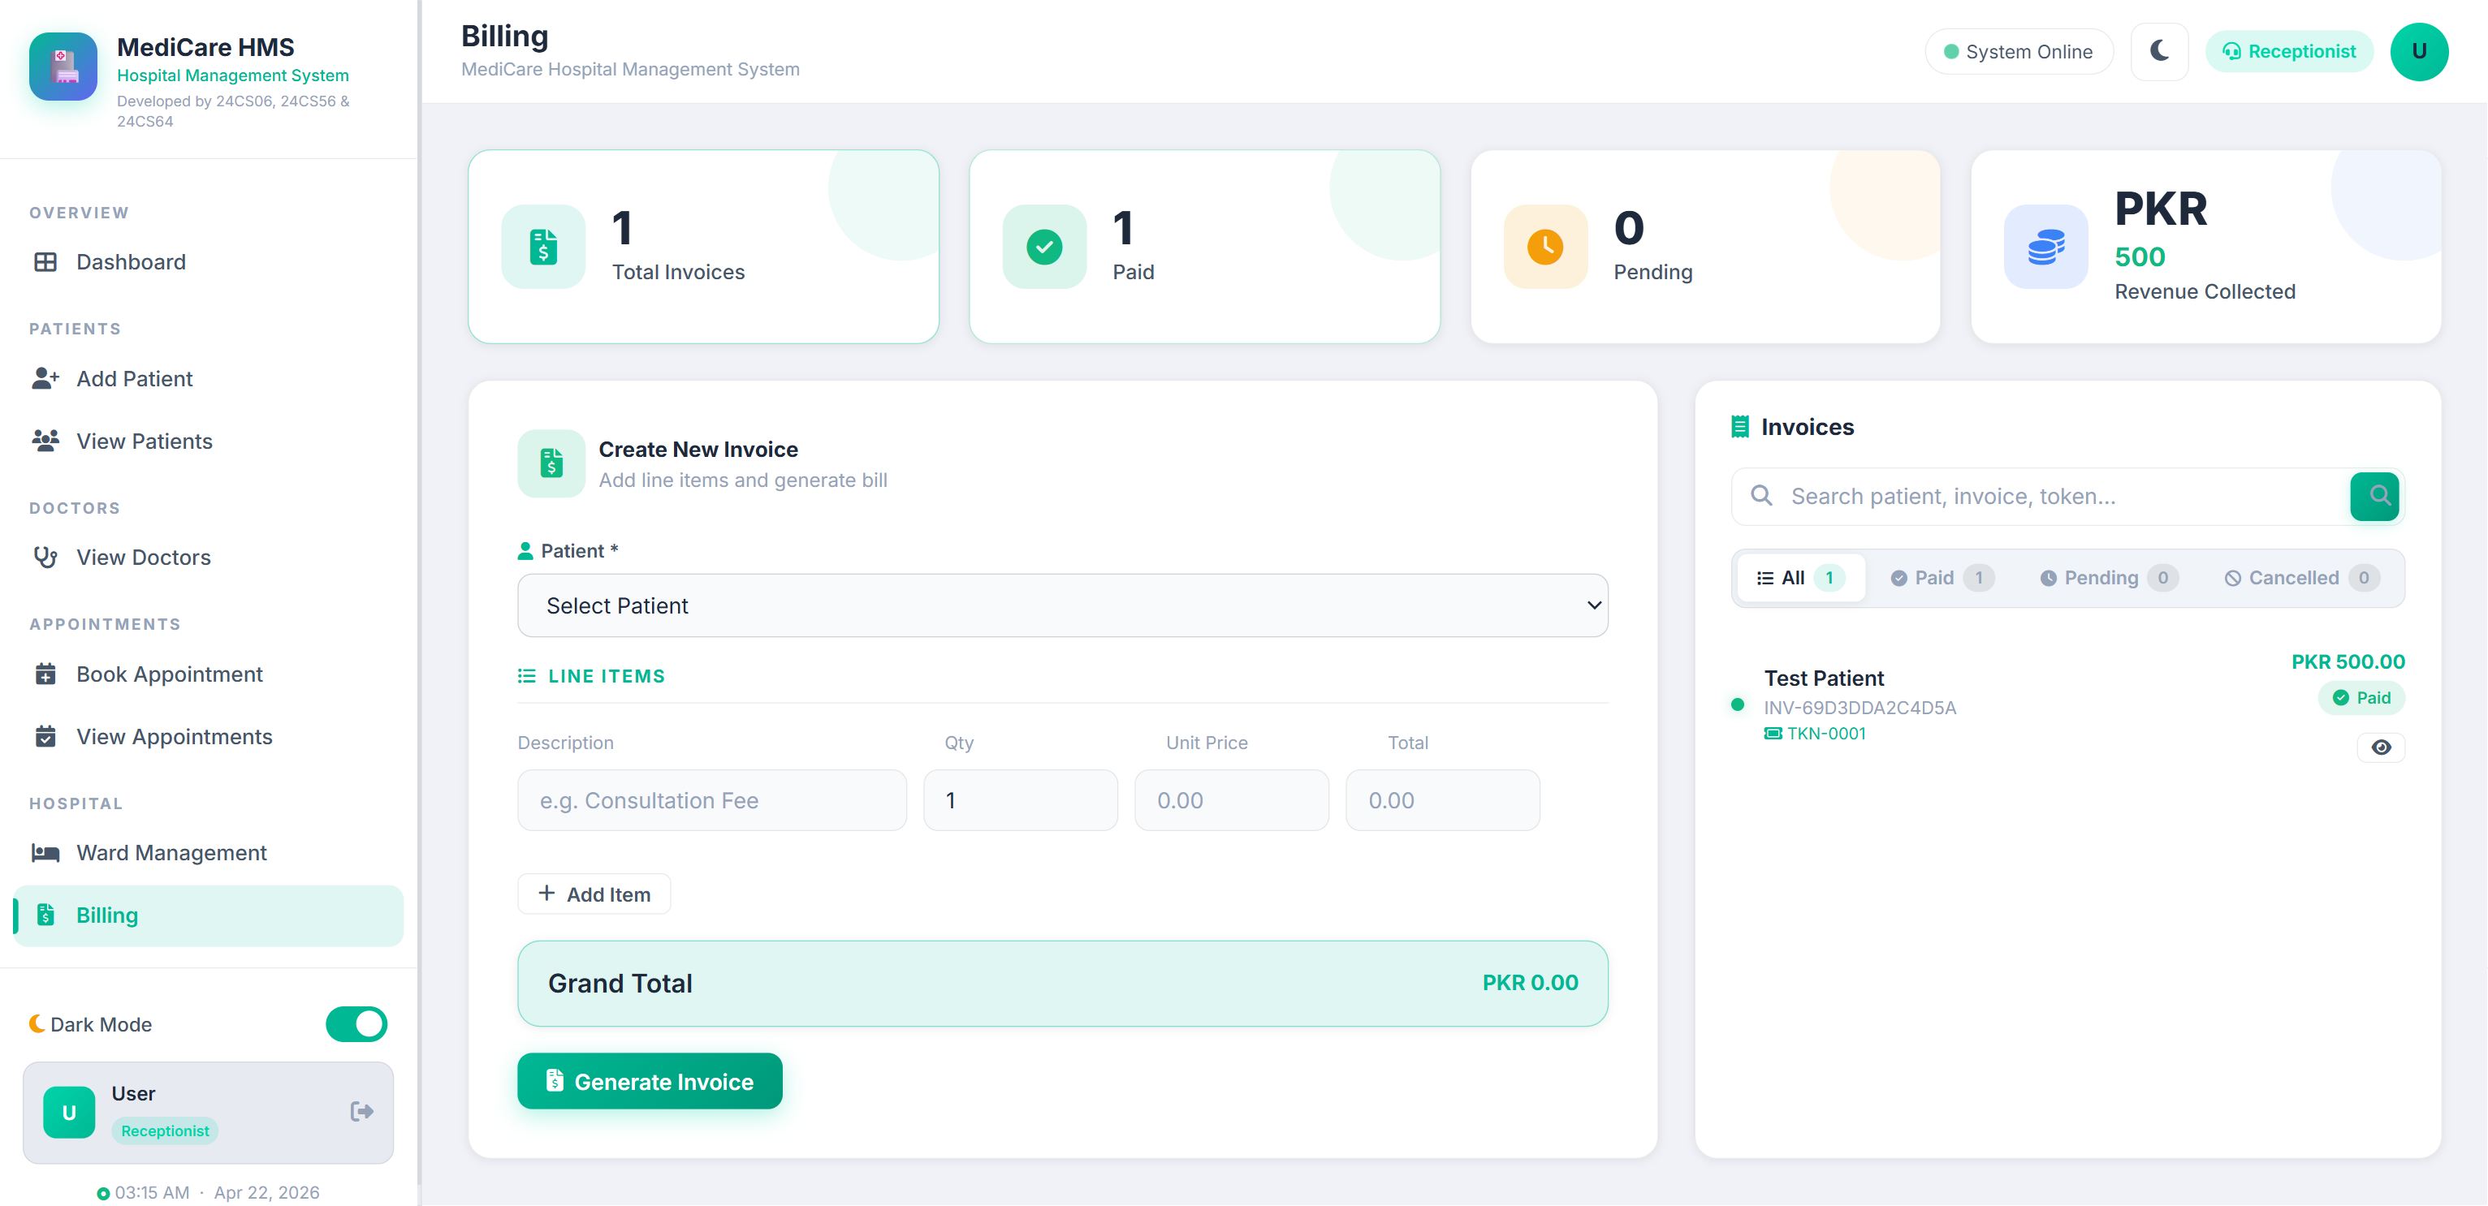

3. Database Schema Design
The system uses a relational schema defined in MySQL with the InnoDB storage engine to support robust relational mapping and transaction properties. The primary entities are outlined below.
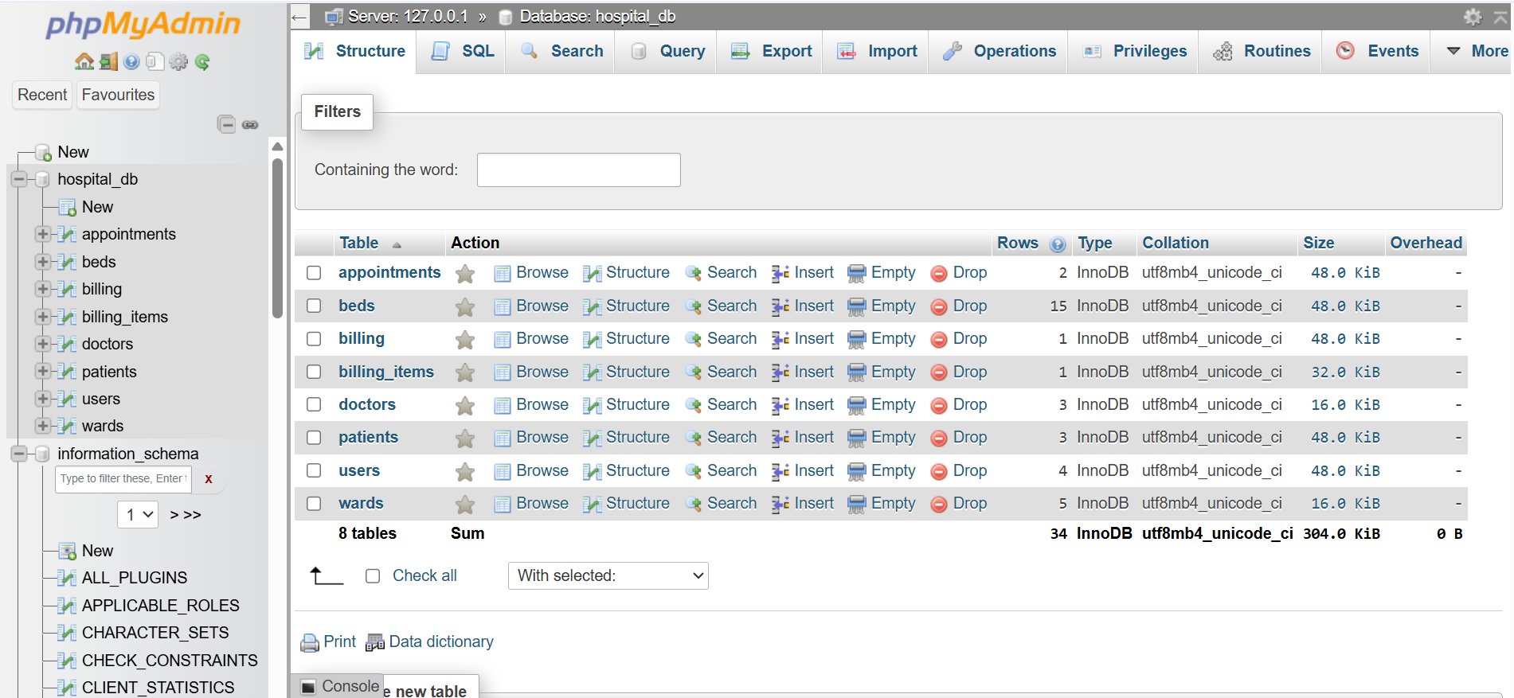

3.1 Schema Description
- patients: Stores demographics and unique token_number ids.
- doctors: Maintains profile elements and specializations.
- appointments: Bridge table associating instances of doctor-patient engagements.
- wards & beds: Relational tree segmenting infrastructure types with foreign keys dynamically assigning beds to admitted patients.
- billing & billing_items: Financial hierarchy isolating overall invoices from their scalar line items.
- users: Encapsulated RBAC authorization table tied to core staff identifiers.

3.2 ER Relationships
• 1-to-N: A patient can have multiple appointments and billing invoices.
• 1-to-N: A ward contains multiple beds.
• 1-to-N: A billing instance acts as a parent to multiple billing_items.
• 1-to-1: A user credential record maps to a specific doctor identifier.

4. Database Normalization
The database adheres strictly to normal forms up to 3NF to avoid insertion, update, and deletion anomalies.

4.1 First Normal Form (1NF)
All tables hold a defined primary key ('id' AUTO_INCREMENT). Attributes contain atomic values only. For example, the 'patients' table does not store multiple phone numbers in a single column; it relies on atomic storage variables.

4.2 Second Normal Form (2NF)
The schema adheres to 1NF. Every non-prime attribute must be functionally dependent on the entire primary key. In the 'billing_items' table, 'description', 'quantity', and 'unit_price' depend specifically on the line item 'id'. They do not depend partially on any other composite key.

4.3 Third Normal Form (3NF)
The schema complies with 2NF without any transitive dependencies. Attributes like 'specialization' or 'experience' reside purely in the 'doctors' table rather than repeating within 'users'. A user's access role does not arbitrarily determine medical expertise. Dynamic states such as 'Confirmed' and 'Pending' are strictly typed and don't duplicate relational string values across scattered tables.

5. Integrity Constraints
To ensure data validness, the following constraints are embedded strictly within the MySQL DDL script:
- Entity Integrity (Primary Keys): id INT AUTO_INCREMENT PRIMARY KEY in all tables guarantees mathematical uniqueness for tuple selection.
- Referential Integrity (Foreign Keys): Deleting a 'patient' executes an ON DELETE CASCADE which drops associative 'appointments' and 'billing' records immediately. Deleting a admitted patient triggers an ON DELETE SET NULL on their bed array, safely freeing the resource.
- Domain Constraints (ENUMs): 'ward_type' is physically restricted to ('General', 'ICU', 'Emergency', etc.). The logical domains behave like CHECK constraints.
- Unique Constraints: Fields like 'token_number' and 'invoice_number' enforce UNIQUE constraints to prevent duplicate external logic.

5.1 Constraint Implementation Snippet
CREATE TABLE IF NOT EXISTS appointments (
id INT AUTO_INCREMENT PRIMARY KEY,
patient_id INT,
doctor_id INT,
status ENUM('Pending','Confirmed','Cancelled','Completed') DEFAULT 'Pending',
FOREIGN KEY (patient_id) REFERENCES patients(id) ON DELETE CASCADE
);

6. Query Processing & Analytics
The application executes complex SQL structures dynamically via PDO.

6.1 Intersecting JOIN Operations
Rendered in 'view_appointments.php', retrieving deep relational context:
SELECT a.*, p.name AS pname, d.name AS dname, d.specialization
FROM appointments a
JOIN patients p ON a.patient_id = p.id
JOIN doctors d ON a.doctor_id = d.id
WHERE a.status = 'Confirmed'
ORDER BY a.appointment_date DESC;

6.2 Analytical GROUP BY Aggregations
Rendered in 'reports.php', calculating monthly throughput trends:
SELECT DATE_FORMAT(created_at, '%b %Y') AS label, COUNT(*) AS cnt
FROM patients
WHERE created_at >= DATE_SUB(NOW(), INTERVAL 12 MONTH)
GROUP BY DATE_FORMAT(created_at, '%Y-%m')
ORDER BY DATE_FORMAT(created_at, '%Y-%m');

7. Transaction Management
The architecture enforces strict transaction safety. Utilizing the InnoDB engine intrinsically supplies ACID compliance (Atomicity, Consistency, Isolation, Durability) equipped with robust crash recovery mechanisms.
The logical backend flow executes Application-Level Transactions mimicking the BEGIN TRANSACTION pattern when bundling parent invoices and child billing items concurrently.

7.1 Transactional Logic Strategy
// billing.php - Maintaining Atomicity during bulk financial interactions
$pdo->beginTransaction();
try {
// 1. Log overall invoice state
$stmt = $pdo->prepare("INSERT INTO billing (...) VALUES (...)");
$stmt->execute([...]);
$billingId = $pdo->lastInsertId();
// 2. Iterate and append segmented invoice data seamlessly
$iStmt = $pdo->prepare("INSERT INTO billing_items (billing_id, ...) VALUES (?, ...)");
foreach ($items as $item) {
$iStmt->execute([$billingId, ...]);
}
// Complete the synchronized commit
$pdo->commit();
} catch (Exception $e) {
// Discard any partial inputs upon hardware or logic failure
$pdo->rollBack();
}

8. Conclusion
The MediCare Hospital Management System embodies a highly structured and optimized Database Management implementation. The robust multi-relational schema normalizes data efficiently while imposing rigid logical constraints. Supported by scalable analytical query patterns and strict InnoDB transactional architecture, the project provides a sound backbone capable of fulfilling real-world medical data requirements successfully.

Rubrics | Poor  (0-2) | Acceptable  (3-5) | Adequate  (6-8) | Proficient  (9-10) | Score (10)
Requirements Analysis and Specification | Incomplete or poorly documented requirements, missing significant details. | Basic requirements covered but missing several details; non-functional requirements are vague. | Good requirement analysis with most functionalities specified but minor details missing. | Comprehensive, clear, and well-documented requirements. Captures all functional and non-functional aspects effectively.
Database Design | Poor design with major redundancy; unclear schema; lacks normalization. | Basic design; significant redundancy; not fully normalized; lacks essential relationships. | Good design with slight redundancy; mostly normalized, minor improvements needed. | Well-structured and normalized ER diagrams; schema adheres to DBMS principles, ensures minimal redundancy.
Implementation and Functionality | Major functionality is incomplete; frequent bugs and usability issues. | Basic functionality achieved; some significant bugs or missing features. | Most features implemented; minor issues or bugs, but overall functionality is solid. | Comprehensive and error-free implementation; all specified features work smoothly.
Data Integrity and Constraints | Little to no constraints applied; lacks data integrity. | Basic constraints applied but key ones missing. | Good constraint management with minor issues or constraints missed. | Enforced appropriate constraints (e.g., primary keys, foreign keys, unique constraints) to ensure data integrity.
Documentation and Presentation | Poor or missing documentation; presentation lacks clarity. | Basic documentation; missing some important information. | Good documentation with minor gaps; presentation is clear but lacks depth in some areas. | Comprehensive documentation (technical and user); project is presented effectively, covering all details.
Obtained Score (OS)
Normalized Score=(OS/50)*10

